# **CTF Topic: Using the WHOIS Tool**

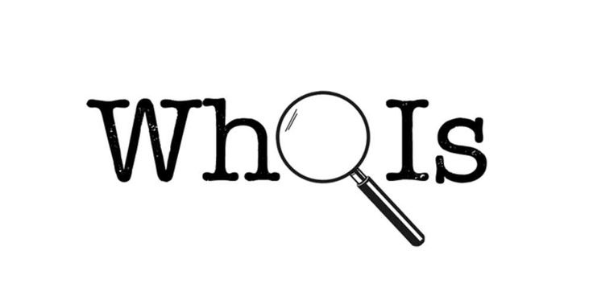

# **Introduction**



WHOIS is a protocol used to query databases to obtain information about the registration of a domain name or IP address. This information can include the registrant's contact details, registration dates, and the domain's status. In Capture The Flag (CTF) challenges, WHOIS can help gather crucial information about domains, which can lead to solving various tasks.

# **Tools and requirements**

* Online WHOIS Lookup Services

# **Scenario**



Imagine you are given a domain name in a CTF challenge. Your task is to use WHOIS to gather information about the domain that might help you find clues or solve the challenge.

# **Process to Perform**

Step 1: Go to your browser and click on the provided link: [www.whois.com/](http://www.whois.com/)

Step 2:Enter the URL: <https://www.tesla.com/> and solve the CTF.

# 

# **Let’s start the Challenge**

# **Question**

Flag1: What is the Registrar of the target website?

Answer: MarkMonitor Inc.

Flag Captured

Flag2: what is the Registry Domain ID?

Answer: 187902_DOMAIN_COM-VRSN

Flag Captured

Flag3: What is the Administrative Phone number of the target?

Answer: +1.14155319335

Flag Captured

# **Hint**

